

New Starter Welcome Booklet
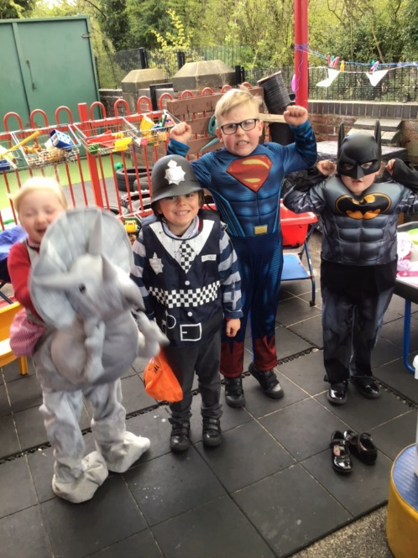
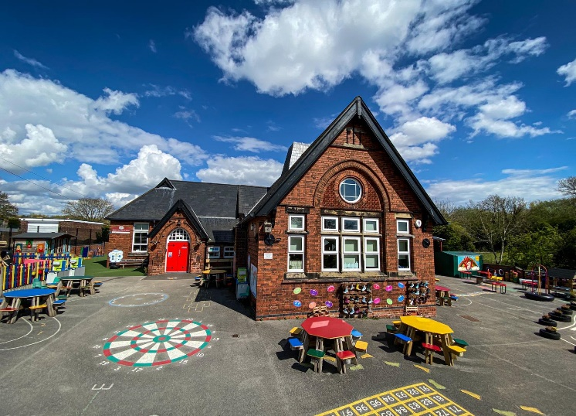

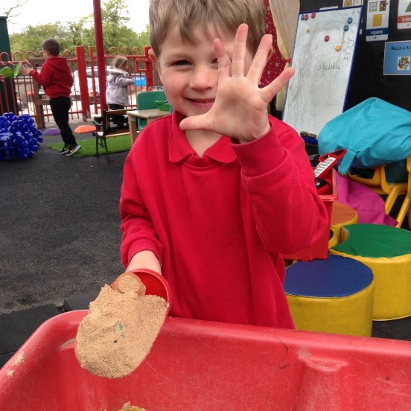







Street Lane Primary School
Street Lane, Denby, Ripley, Derbyshire DE5 8NE
01773 742717 – 07790 279817 – info@streetlane.derbyshire.sch.uk
Headteacher – Mrs Natasha Austin-Cooke

Our Vision
“Each and every child is special to us. Throughout their learning journey we aim to develop self-belief, confidence, positive well-being and independence in a culture of mutual respect. We want our children to be the best that they can be”.
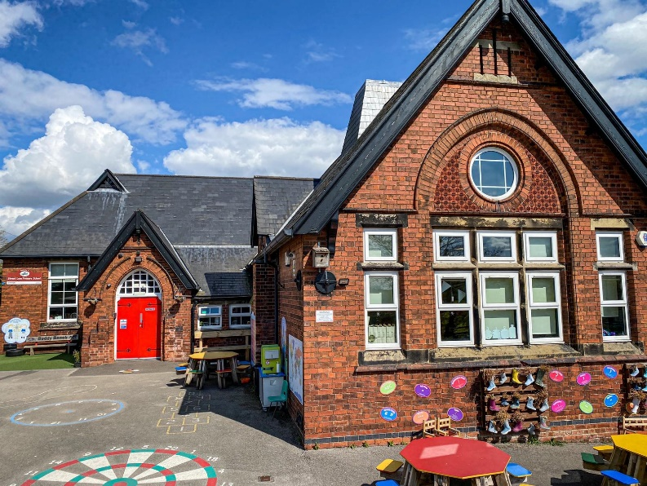

We would like to offer you and your child a very warm welcome to Street Lane Primary School. We are delighted that you will be joining us in September and we are looking forward to getting to know all of our new children and their families.
This booklet is designed to offer information about our school and how we will ensure a smooth transition for your child. Starting school is an exciting time and your child will be facing new challenges and experiences. We are here to fully support both your child and yourselves and ensure that your child’s transition into our Ducklings Class is smooth and successful.

Duckling Class Staff
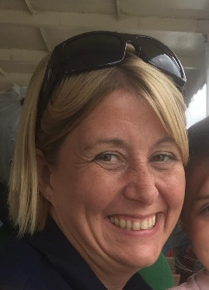



Miss Johanna Matich
Mrs Chloe Curtis
Mrs Tracey Dixon
Mrs Dixon and Mrs Curtis are the Deputy Headteachers at Street Lane Primary school and the Ducklings and Parrots Class Teachers.
In September Mrs Curtis will be teaching on a Monday, Tuesday and alternative Wednesdays and Mrs Dixon will be teaching on alternative Wednesdays, Thursdays and Fridays. Miss Matich will be teaching the class when Mrs Curtis and Mrs Dixon have PPA or management time on a Wednesday.



Mrs Walker
Mrs Dorman

Mrs Walker and Mrs Dorman will be the teaching assistants working in the Ducklings and Parrot Class. Our class is a mixed EYFS and Year One class with the EYFS children as our Ducklings and the Year One children are our Parrots.

Transition

If your child is currently in a Nursery or playgroup setting, Mrs Dixon or Mrs Curtis will contact their current teachers to try to arrange a time when we can visit. If this is not possible due to current restrictions we will have a telephone conversation and request that the setting send us any assessment information that they have for your child.
We would like to invite your child to our transition afternoons at Street Lane Primary School which will be taking place on Thursday 1st July and Thursday 8th July from 1.30-2.30.
As it will be your child’s first experience at school we have planned two short sessions where they can play with us and get to know us without being worried that they are away from carers for a long time.
Mrs Dixon and Mrs Curtis will both be in school for these afternoons so the children will be able to meet both of their teachers. A teacher will meet you at the school gate and support your child as they come into school. We will have lots of fun activities for the children to access and enjoy.
On Thursday 24th June you are invited to our New Parents Information Evening. Please bring your child along with you and we will have staff available to play with and care for your child in the classroom whilst Mrs Dixon and Mrs Curtis welcome you to our school. After the meeting we will show you around the school. To allow this to happen under current restrictions we are asking that you complete a lateral flow test prior to attending the meeting. This is to ensure the safety of our staff and children whist enabling our new parents to see the learning environments that your children will be accessing in September.

Mouse Club


Mouse Club is a new initiative we are starting for the academic year 2021-2022. Each of our new children will receive a mouse as a gift. Mouse is a special friend who will help with their transition to school. Throughout the year we will suggest activities that your child may want to do with Mouse and this will help your child grow in confidence and share their learning with you at home.

The Parental Engagement Network developed Mouse Club to;

•Improve emotional wellbeing therefore, improve progress

•Support and improve transition

•Support home routines

•Support separation anxieties

•Support your child in getting ‘Ready for School’

After our New Parent Information Meeting we will give your child their mouse with a booklet of suggested activities for you to share together.

When your child starts school in September they may bring their mouse to school and they will live in their special mouse house in the classroom. This will be a shoe rack where the children each have a photograph in a pocket for their mouse to live.

The children will be able to play with their mouse during independent learning time and Mouse will always be available for a cuddle if your child is feeling unsettled.

Once your child has received their mouse, we advise that you use them at home to help prepare your child for school. We have found that Mouse can help with establishing routines with your child which will help them when they attend school every day.

Mouse can help with;

Brushing teeth

Making healthy choices

Sharing stories

Mouse can also help with the 10 keys for unlocking school readiness suggested by Derbyshire.

I can settle without my parent or carer

I can tell grown-ups and friends what I need

I can take turns to play and share when I’m playing

I can go to the toilet on my own and wash my hands

I can put on my own coat and shoes and feed myself

I can tell a grown-up if I’m happy, sad or cross

I know that what I do and say can make others happy or unhappy

I am curious and want to learn and play

I can stop doing what I am doing, listen and follow simple instructions

I enjoy sharing books with grown-ups

Once your child has settled into school they may not feel that they need to bring Mouse every day. There may be times when they need Mouse more than others. This is fine and will be child led. If a child is seeking comfort from Mouse more frequently then this may indicate that they are anxious about something and we can find ways to help them overcome their worry.

Our School Day

Breakfast club is open from 7.30am for children. Last entry for breakfast is 8.15am. However, if you would like to arrive at school prior to 8.50am then £4 is still payable regardless of whether they eat.

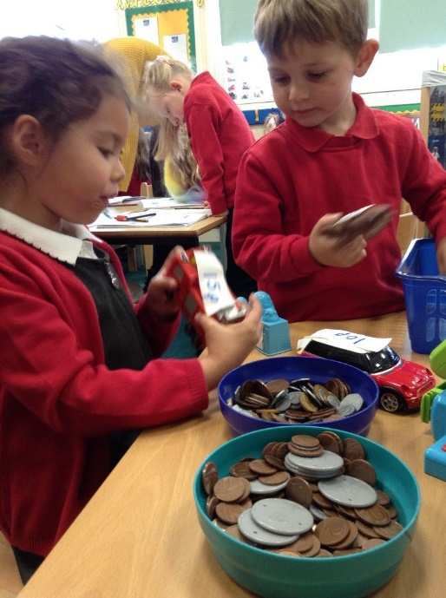
The school doors open at 8.50 am for a 9am start. We will be encouraging children to separate from parents and carers at the school gate and a member of staff will escort your child into school. We believe that this promotes independence for our new children and ensures that they settle quickly ready for the day. The children will have their own coat peg and tray for their book bags and we will encourage the children to be responsible for putting their own belongings away. However, there will always be adults on hand to help if they are unsure. There will be activities ready for the children to engage with as soon as they are in school.

Please make sure that your child’s belongings are clearly labelled with their name. Your child does not need to bring a large bag to school. We ask that your child brings a book bag only and a lunchbox if they have a packed lunch. Children are expected to bring a water bottle into school with water in everyday and this is readily available throughout the day.

Morning break is at 10.30 until 10.45. Fruit is available for your child and children under 5 will be entitled to a drink of milk in the morning. You are welcome to provide a healthy snack for your child and school offer healthy snacks for the children to purchase for 30p.

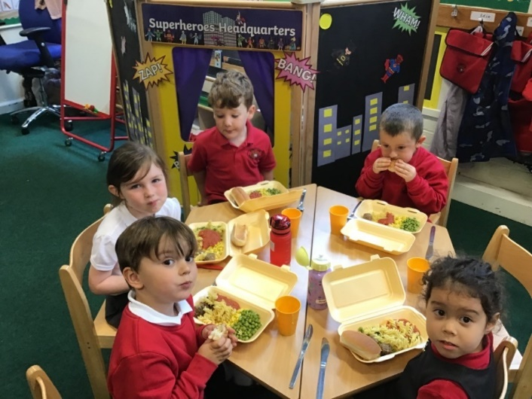
Lunch begins at 12.00 and the children eat their meal in the classroom. A free hot school meal is available daily for all infant children. Hot meals are served to the children by the lunchtime staff. Children may bring a packed lunch to school if you would prefer. After lunch the children have playtime on the main playground and so have the opportunity to play with the older children.
Collecting Children
The school day ends at 3:30p.m and children are dismissed to parents or guardians one at a time by a member of staff. Children will leave through the red gate located on the right-hand side of the school. Parents will wait by the gate so that the adults can see who is picking each child up.
In your welcome pack you will find a form entitled ‘Permission to Collect.’ We ask that you provide the names of four adults who you give permission to collect your child. We will only dismiss your child to the adults named on this list. Children must be collected by an adult or someone who is 16 or over. If you require a different adult to collect your child we ask that you contact the school office and leave their name and a password. The safety and welfare of our children is of the upmost importance.

Learning in the Ducklings Class
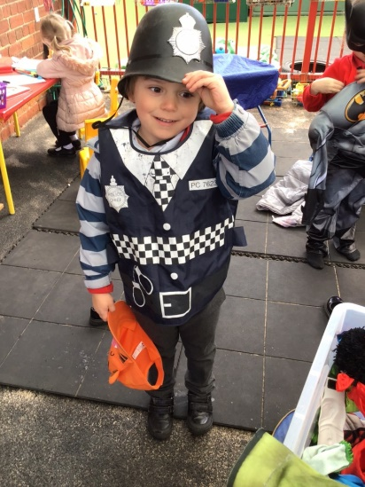
At Street Lane Primary School, we want every child to:
Be healthy and safe
Enjoy school and achieve
Make a positive contribution
Achieve economic well-being

As your child starts at Street Lane Primary School they will be accessing learning from the Early Years Foundation Stage Profile.
The EYFSP is the curriculum document that we follow for the first year of school. Your children will already have achieved parts of the profile as it covers their development from birth. Any previous setting that your child has attended will have highlighted developmental points that your child has achieved.
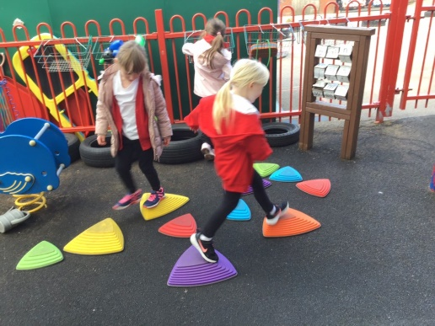
The EYFSP is divided into seven areas of learning, three prime and four specific.
Communication and Language
Personal, Social and Emotional Development
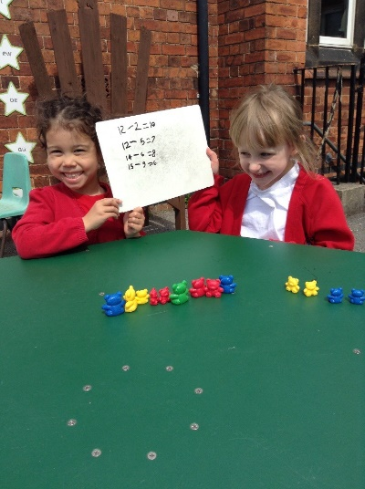
Physical Development
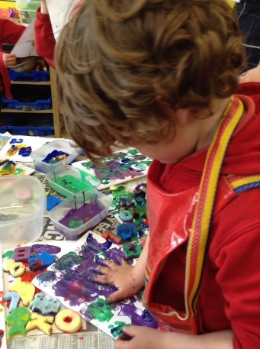
Literacy
Mathematics
Understanding of the World
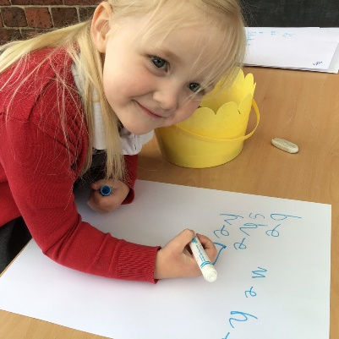
Expressive Arts and Design

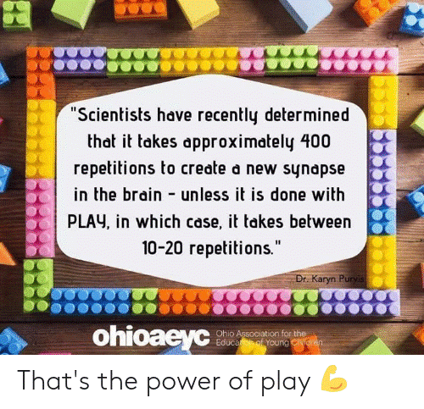
We teach this curriculum through play!

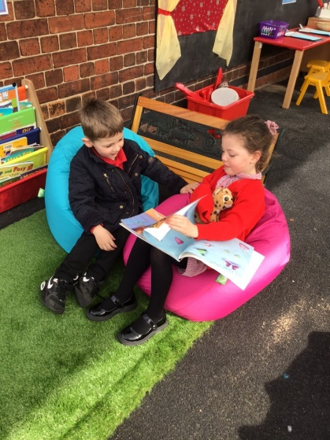
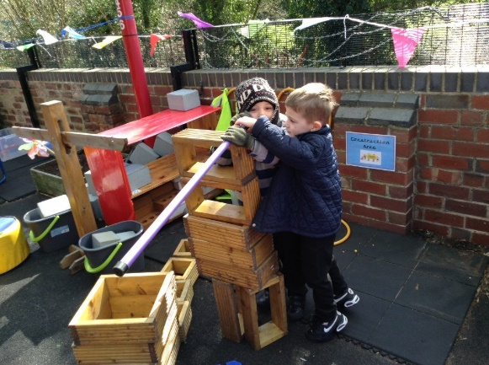
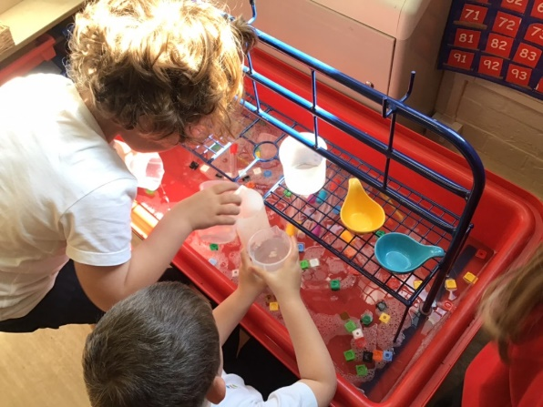
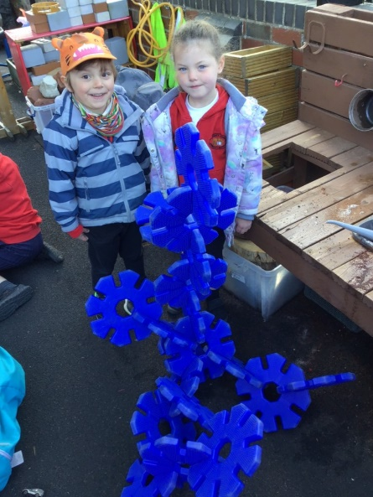

The children will have a mixture of directed teaching sessions and independent choosing time.
Directed teaching time will be short bursts throughout the day. We will have daily Phonics, Maths, Funky Fingers and ECaT (Every Child a Talker) sessions which will last between 10 and 15 minutes.
Throughout the week the children will also be taught PE and RE as a focused session. Other subject areas are covered through our continuous provision planning. This is often child led but we will also provide appropriate adult led enhancements.

Outdoor Learning

Whenever possible we operate a freeflow classroom so the children can decide for themselves if they wish to learn inside or outside. We make regular use of our beautiful outdoor spaces to support the children’s learning.
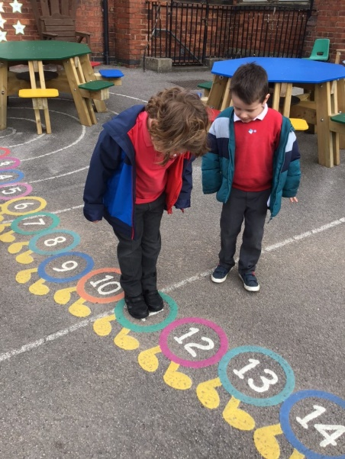
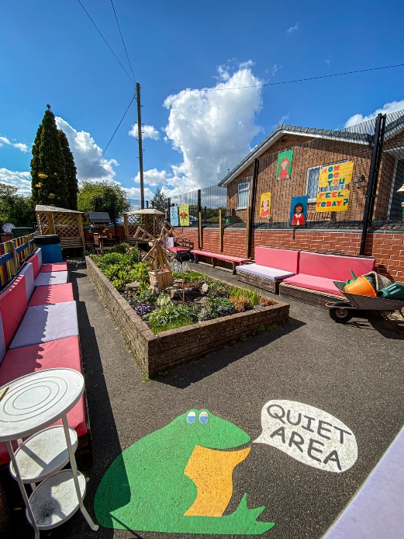
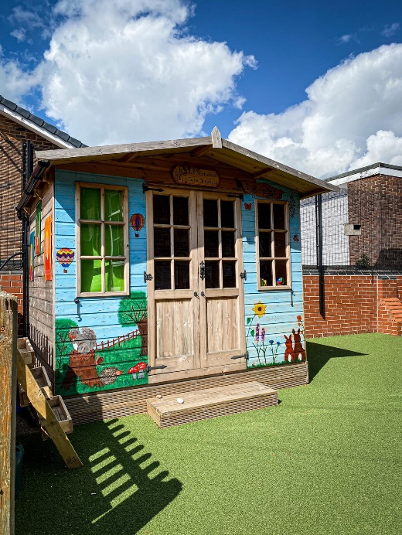

We will access the outdoor area whatever the weather! So please ensure that your child has a warm, waterproof coat with a hood.

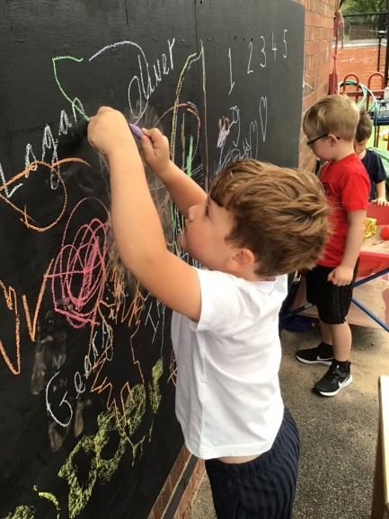
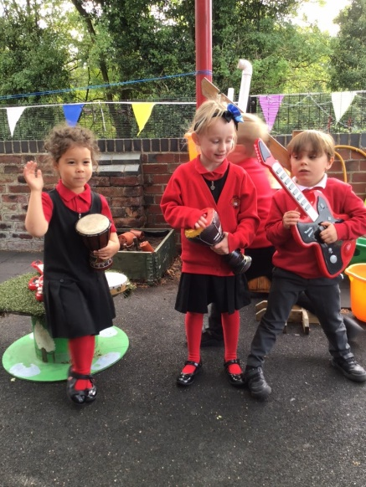
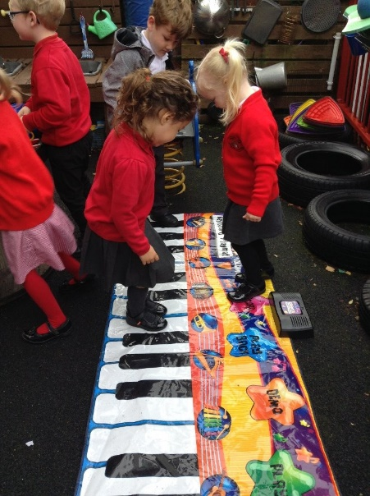

What will your child need?
- School uniform- please name all items
- Black school shoes with Velcro fastenings if possible
- Book bag for reading books, please ensure that your child has this in school every day
- A named water bottle – please fill with water not juice
- PE Kit
- A warm coat for outdoor play
On the day we have PE we ask that the children come to school dressed in their PE kit. This is to avoid the lengthy changing time which results in shorter time for activity. It also reduces the amount of lost clothing!
Children may wear studded earrings but these must be removed on PE day.
We recommend that long hair is tied back- especially on PE day.

For details of school uniform and PE kit and ordering details please refer to the school website.

Home School Links
Throughout the school we use the online learning journal Tapestry to enable us to communicate with you about your child’s personal learning experiences.
Tapestry allows us to share photographs of your child learning in school and playing with their friends during the school day. We will describe the activity they are completing and link it to the learning intentions taken from the EYFSP.
Tapestry is an extremely valuable tool for us as it allows you to upload photographs of descriptions of activities that your child has completed at home. You may also wish to share details of experiences that your child has had which can prompt your child to discuss them in class. Encouraging your child to develop the confidence to speak in front of their peers is an important part of learning in Early Years. We love to hear the children describe events from home and using photographs can help us to support children who are reluctant to speak or who are very shy.
From September we will be using principles from the Every Child a Talker initiative to raise standards in Communication and Language. Each week we will share an ECaT sheet with you which will include information of our focus story for the week, a song that links to our theme and a variety of suggested activities that you may wish to complete with your child. You can then either return the work to school or upload it onto Tapestry and we will give your child the opportunity in class to share their work and to describe it to their friends.
We will provide you with further details of these home school links at our New Parents Information Evening in June.


And finally…
Staff are on the playground every day before and after school. Please do not hesitate to see us if you have any questions or concerns. If you wish to speak to a member of staff at any other time, please call the school office to make an appointment.

We hope that your child will enjoy their time at Street Lane Primary School and we will make every effort to ensure that this happens.

If you have any concerns before your child starts school, then you may email the school on
info@streetlane.derbyshire.sch.uk



